Health and Wellness Part I
READ | Read books about Health and Wellness.  There are many read-alouds available on Youtube.com. Here are a few:  Germs! Germs! Germs! https://www.youtube.com/watch?v=Bqozl-9WYgM  Corduroy goes to the Doctor https://www.youtube.com/watch?v=wYpXpQilajM  Just going to the doctor https://www.youtube.com/watch?v=bN8e4J0X9tM
SING | SING a funny song about brushing your teeth: https://www.youtube.com/watch?v=k7KarL8S9yY  Use hand motions to add to the song. For example, when singing “Brush Song” pretend to brush your teeth along with the song
PLAY | Create a dramatic play area to engage your child in learning:  - Set up a pretend doctor’s or dentist office.  - Gather some supplies that can be used in place of tools that can be found at a doctor’s office. Here are some examples:  - A toilet paper tube to look at patient’s eyes and ears  - An empty pen or turkey baster to use as a syringe  - Pieces of cloth or towels to dress the “wounds” and make “casts”  - Empty vitamin bottles or other containers  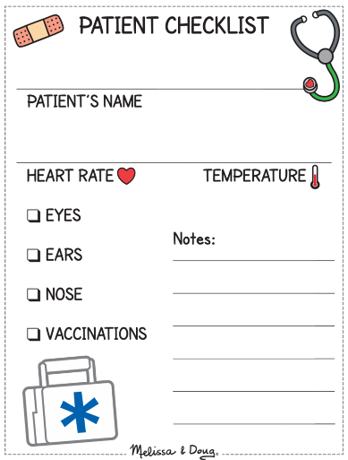  - Plastic spoons  - Make a DIY stethoscope using a funnel, or just out of yarn and paper  - ADD PRINT by labeling various areas where things are stored (bandages, medicine, etc.)  - Gather some stuffed animals or dolls to be patients  - EMBED OPPORTUNITIES FOR WRITING by documenting each patient visit with the help of something like this.  - Line up the “patients” and pretend to treat them for various ailments (cough, broken arm/leg, tummy ache, cut, etc.)  - Show/teach your child how to use the step-by step list to add structure to their play if needed.  - Also included a visual to help “patients” point to the hurt part of the body. This activity is especially important to practice with children who are unable or unlikely to communicate their hurt or discomfort.  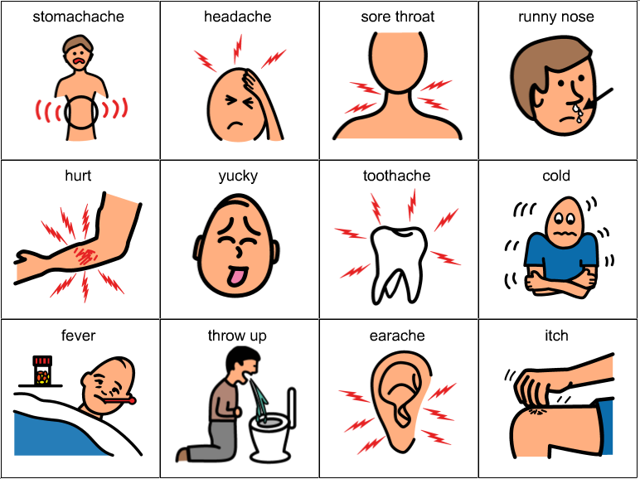  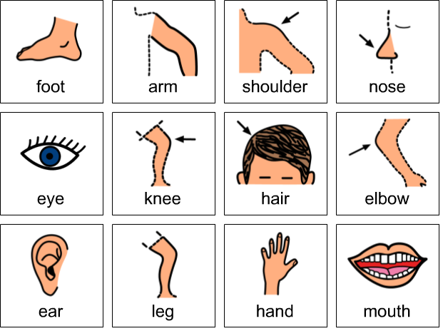
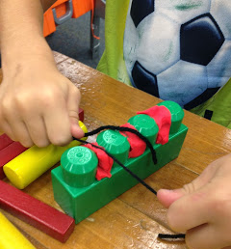
Pretend to floss some huge “teeth” with the help of some mega blocks, playdoh and yarn.
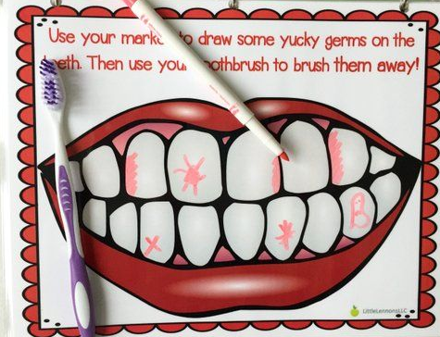
Laminate or put the Teeth attachment sheet inside a sheet protector. Use a dry-erase marker to draw plaque on the teeth. Give your child a toothbrush and ask them to clean the teeth.
TALK | Use a social conversation script when pretending. Change the script as you see fit for your child.  Doctor: Hello. What is hurting you?  Patient: My tummy hurts and I am sneezing a lot (ACHOO!)  Doctor: OK, I can help you with that.  After the doctor treats the patient:  Patient: Thank you doctor! I feel much better!  Does your child use CORE or an AAC device to communicate? Here are some common core phrases you can model for you child when playing (point to each of the words as you say it): I need help. I am hurt. Let me see… Let me hear…. Do you hurt in your... I can help… Do you have… Sit and wait here. Don’t get discouraged if your child doesn’t seem to be paying attention to your pointing. You are simply modeling the use for him/her.
CREATE | 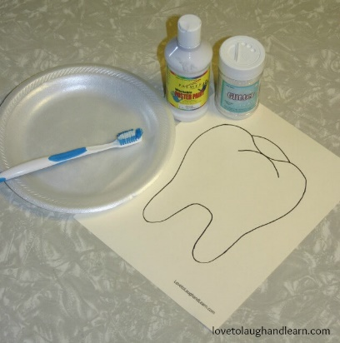  Work on art projects with your child to support their fine motor skills:  Materials Needed:  Tooth template  Cream colored construction paper or cardstock  White paint  White glitter  Inexpensive toothbrushes  Plate to put paint on  Instructions:  - Print off the tooth template onto a cream colored cardstock or use the template as a pattern to trace onto a cream colored piece of construction paper. The reason I am suggesting cream colored paper is so that the child can see the difference between the cream colored “dirty” tooth and the sparkling white tooth after it gets “brushed”.  2. Pour some white paint onto a paper plate.  3. Mix some of the white glitter into the paint.  4. Use the toothbrush to “brush” the tooth with the white paint and glitter.
WRITE | Use the Hygiene Sentences attachment to describe what each of the children in the pictures is doing. As practice or if your child is not yet writing, use the sentence strips. Cut out each word and have your child put them in the correct grammatical order or match it to the correct picture. Prompt your child to make his or her own getting ready schedule with pictures, for an additional challenge add time to each of the activities.  Ask your child to write a letter thanking a doctor or a nurse.
EXPLORE | Talk to your child about the reasons for washing their hands. Do this famous glitter hand washing experiment together:  - Put some lotion on your child’s hands  - Have them rub their hands together to spread the lotion evenly.  - Put some glitter on their hands. Ask them to rub their hands together again.  - Now offer your child a napkin or a paper towel to wipe their hands with. Did the glitter disappear?  - Ask them to wash their hands with just water. Is the glitter still there?  - Now wash hand with water AND soap. Check for glitter again. Hopefully, it’s mostly or all gone.  - Explain to your child that glitter is like germs, we need to really wash hands well to get rid of them.  - Record your observations using the template below or sketch your own.  Here are visual directions for the experiment:  What do you think will happen after you clean your hands with……..? (prediction)  Paper towel  Water  Water and soap  What actually happened? (results)  Paper towel  Water  Water and soap
MAKE | Make hand sanitizer together.  You will need:  ¾ cup of rubbing alcohol  ¼ cup of aloe vera gel  10 drops of essential oil or lemon juice  - Pour all ingredients into a bowl (ideally with a pouring spout like a glass measuring container)  - Mix with a spoon and then beat with a whisk to tur the sanitizer into a gel  - Pour ingredients into an empty bottle for easy use  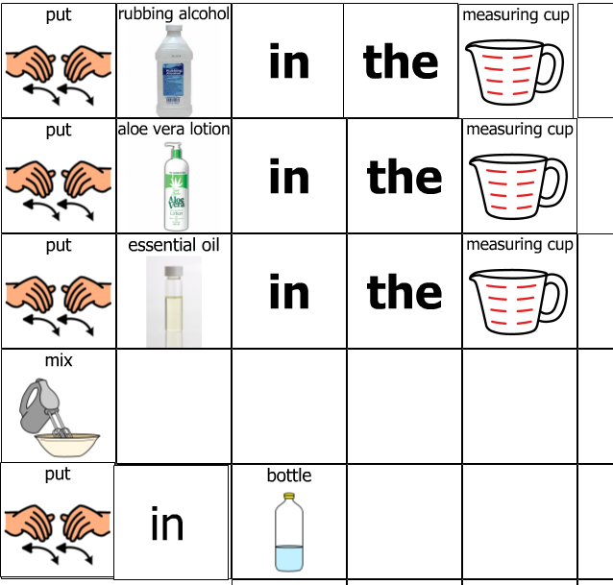
Measure  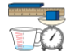 | - Use a thermometer to measure everyone’s temperature in your household. Compare the results.  Talk about what temperature is considered normal and when it is time to see the doctor.  - Use measuring cups to prepare the hand sanitizer ingredients before mixing.  - Count each other’s pulse for 10 seconds and compare the totals.  Engage in an activity that causes one’s heartrate to increase (jumping jacks, clapping really fast, etc.) and count your pulse again.  - Talk about measuring activities in terms of time. How long does it take to perform each of the hygiene tasks for different family members?
COUNT | - Practice counting to 10 or 20 when scrubbing hands clean. OR count backwards from 20 or ten.  - Count the left-over pieces of glitter after each phase of the experiment. Compare the results after each phase.  - Complete the Doctor Tools Counting book (attached)

